# Creating a Khan Academy Account - Parent

## **Step 1: Creating Your Parent Account**

First things first: if you don’t already have one, you’ll want to create an account for yourself. To do this, go to the [Khan Academy home page](https://www.khanacademy.org/) and then click on the **Parents** button**.**

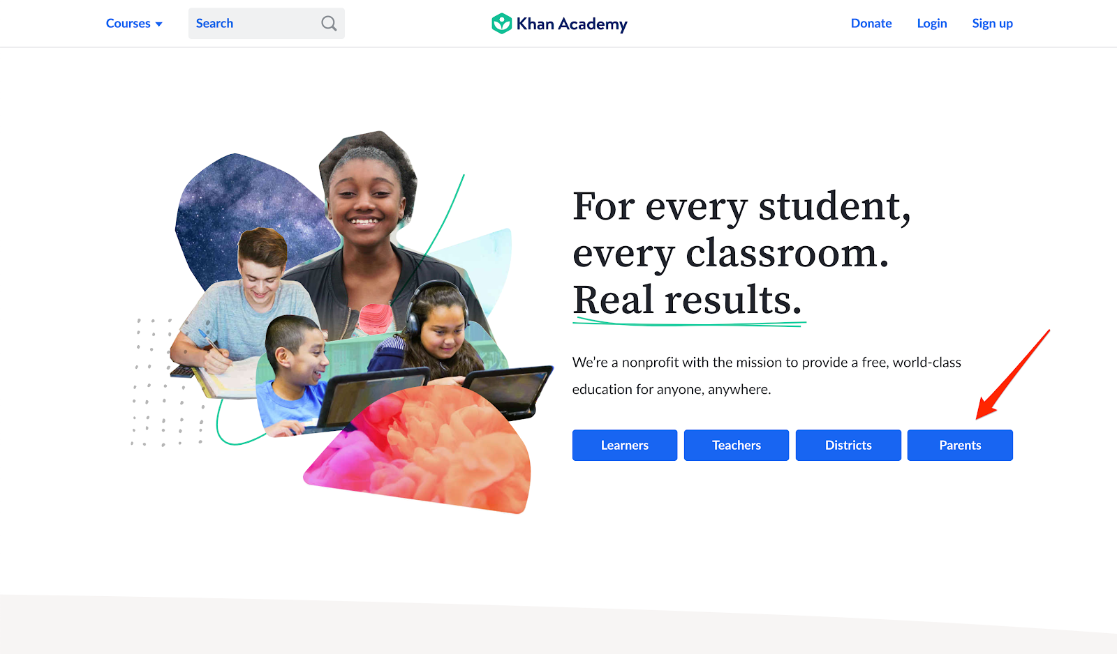

You’ll have the option to sign up with a Google Account, a Facebook account, or with an username or password. Use whichever option works best for you.

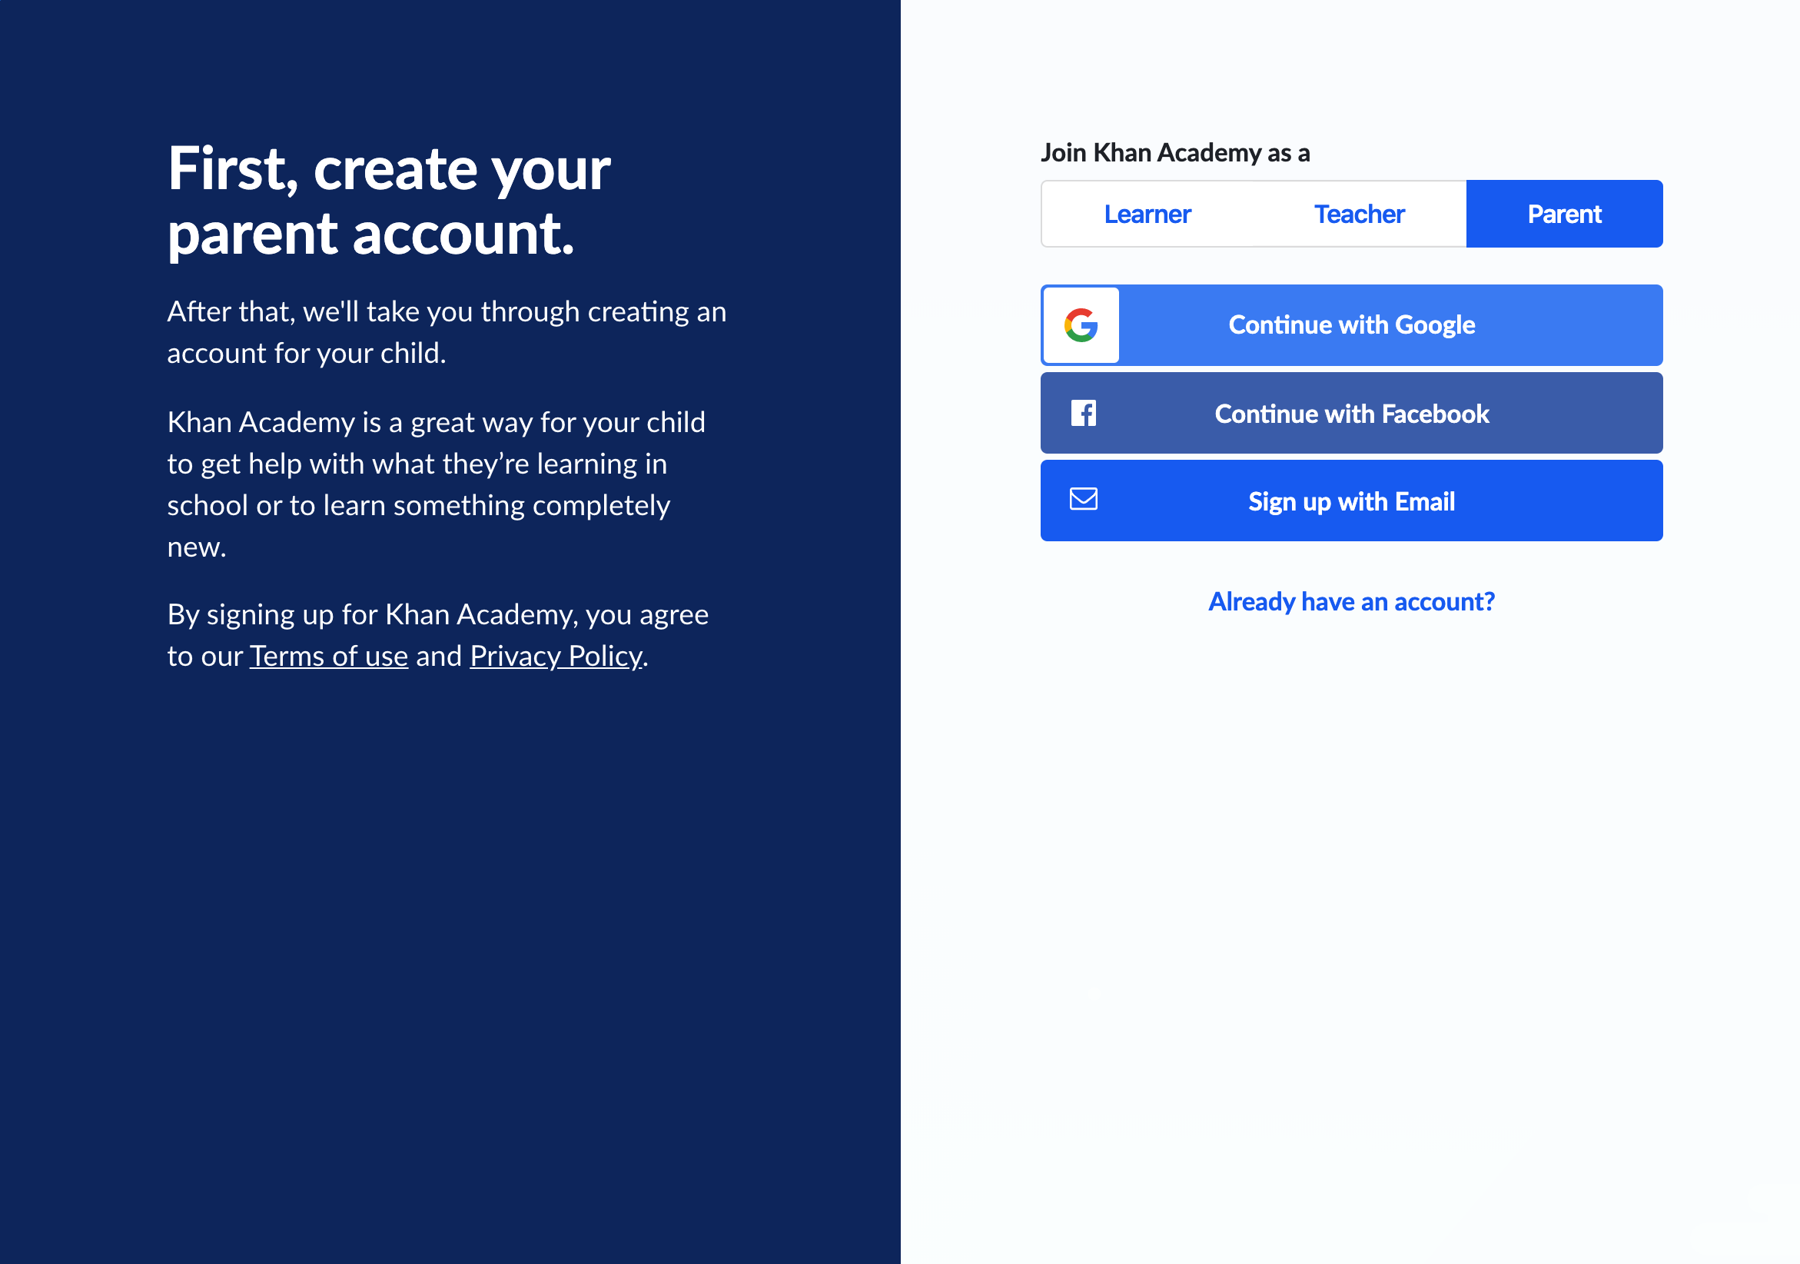

## 

## **Logging Into Your Existing Account**

If you already have a Khan Academy account (even if you weren’t previously using it as a parent), you can log into it by clicking on **Login** at the top right corner of the page:

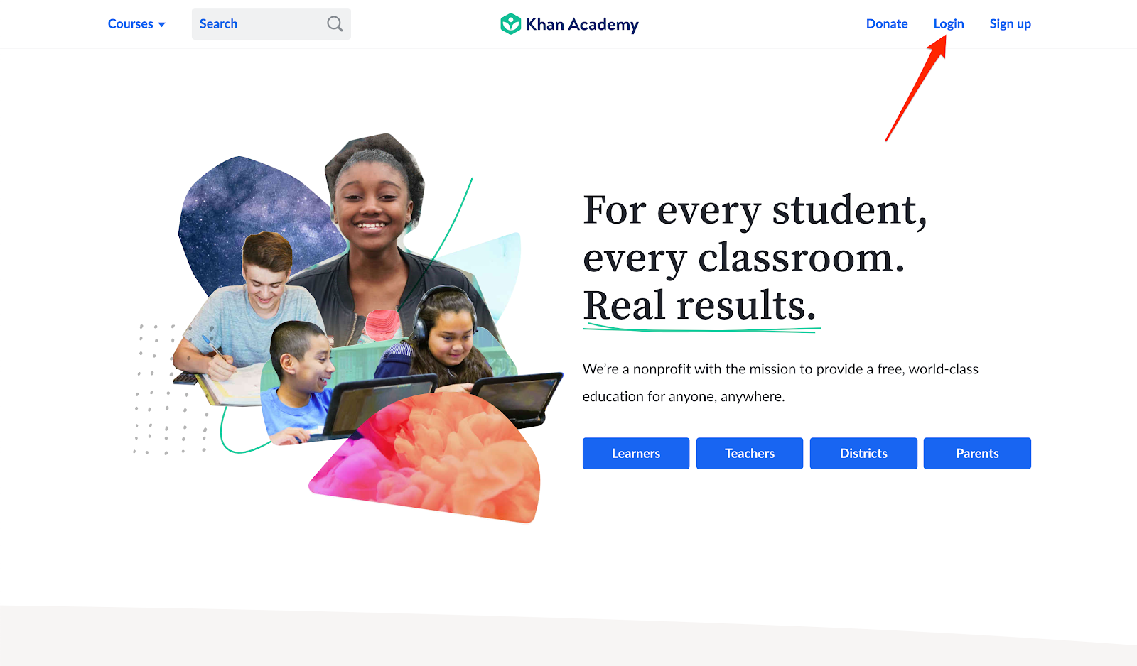

## **Steps 2 and 3: Viewing Your Dashboard and Creating an Account for Your Child**

Once you’ve created your account or logged into your existing account, you’ll be taken to your Parent Dashboard. If you’re not automatically taken to your Parent Dashboard, you can find it one of two ways.

First, you can find it by clicking on your name in the upper right corner of the page, and then clicking on **Parent Dashboard** in the drop-down menu.

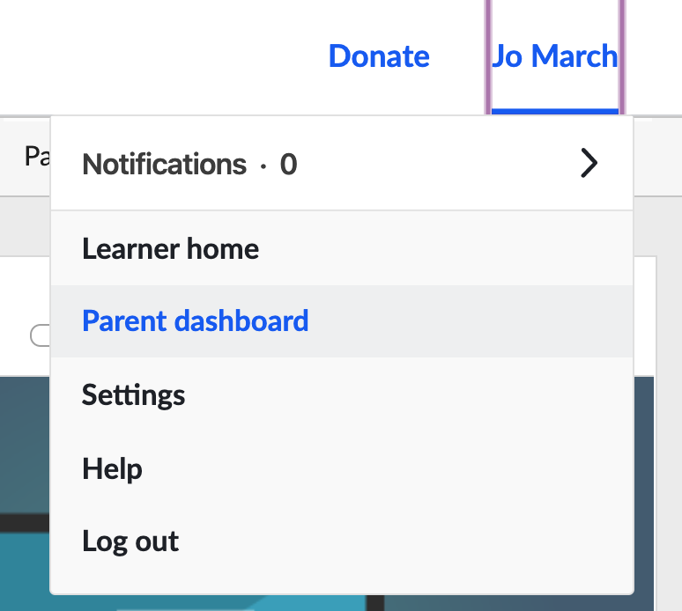

Second, if you do not see the **Parent Dashboard** option in the drop-down menu, you may need to click into your **settings** and scroll down to **Roles.** From here check the **Parent checkbox** and select the **Parent Dashboard** to be your **Homepage.**

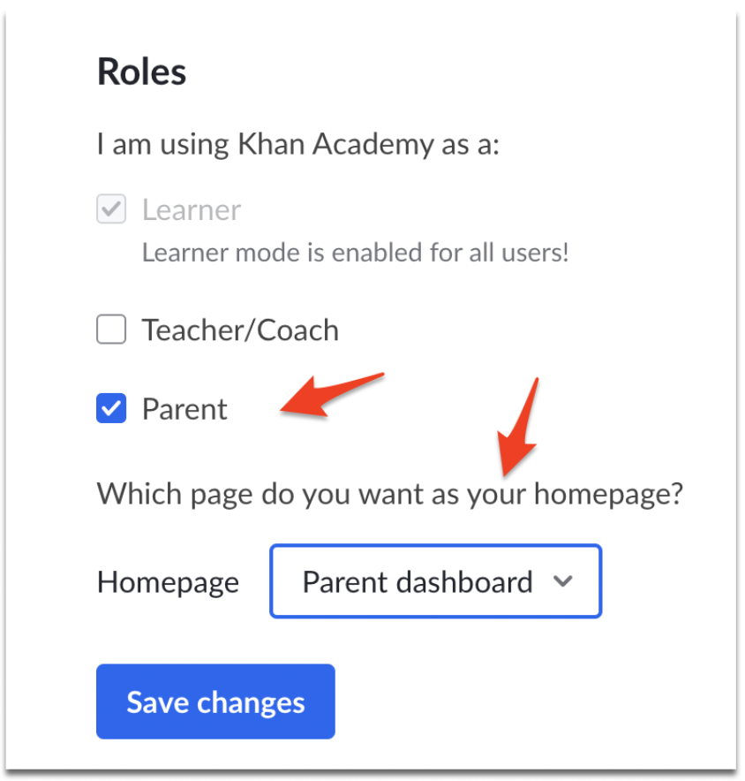

If you’re viewing your Parent Dashboard for the first time, you’ll see a welcome message and then your empty Parent Dashboard. To connect with your child, click on the **Add a child** button**.**

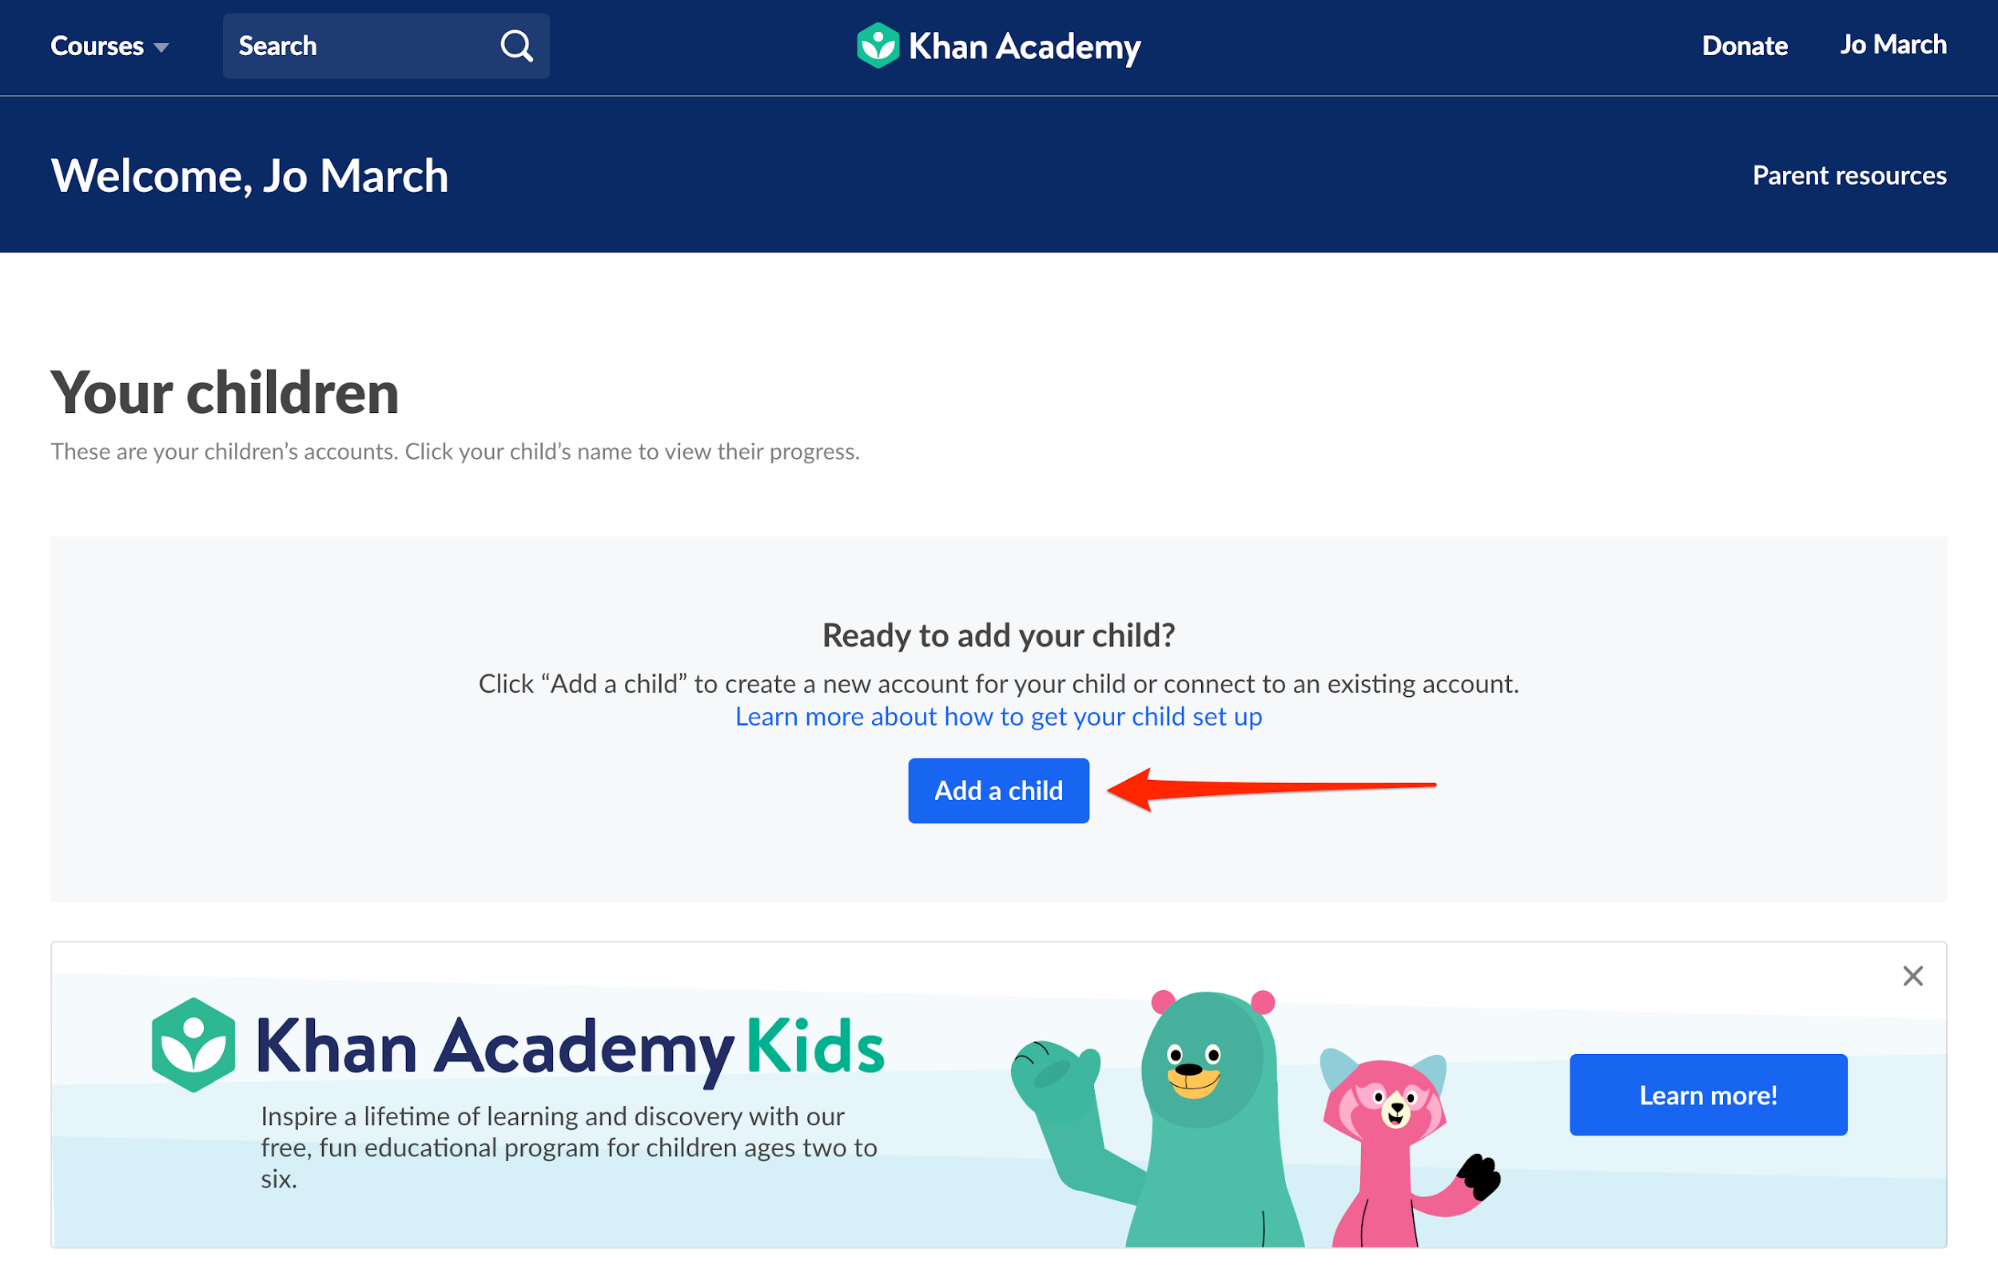

You’ll have different options for adding your child depending on their age and whether they already have a Khan Academy account.

### 

### **Adding a Child Who Already has a Khan Academy Account**

If your child already has a Khan Academy account (for instance, an account they use at school), you can connect to that account as a parent! This way, you’ll have access to their progress made at school, their teacher will be able to see any work they complete at home, and you don’t have to worry about juggling multiple accounts.

To add your child’s existing account, click on the **Add a child** button in your Parent Dashboard, and then click **yes** on the pop up asking if your child already has an account.

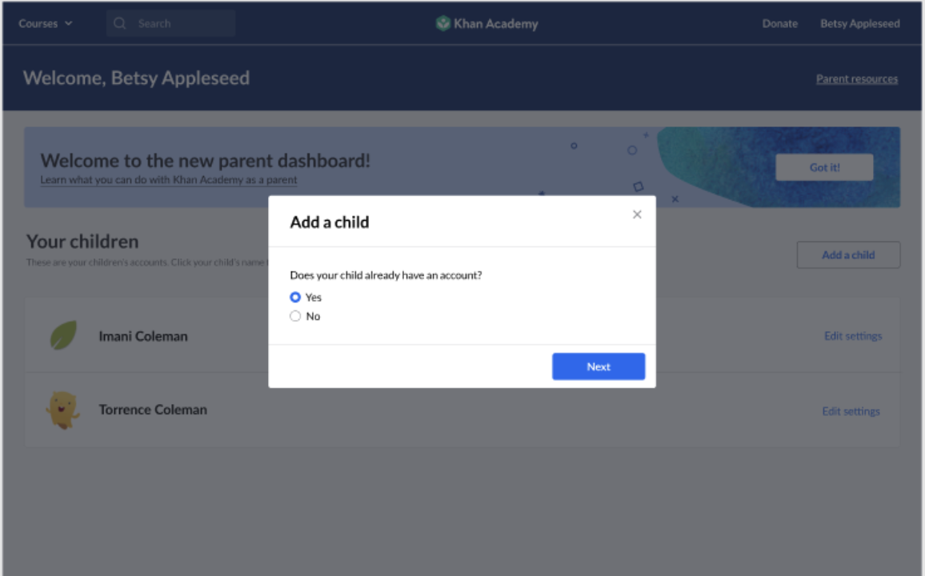

Enter the email your child used to create their Khan Academy account (if your child created their account at school, it’s likely to be their school email), and then click **Send invite**.

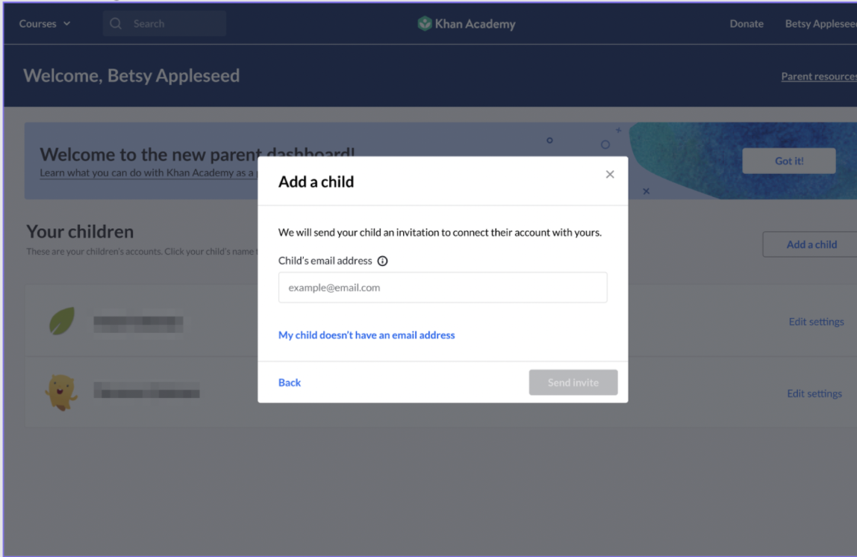

If you go back to your Parent Dashboard, you'll see their name and a message confirming that your child has been invited:

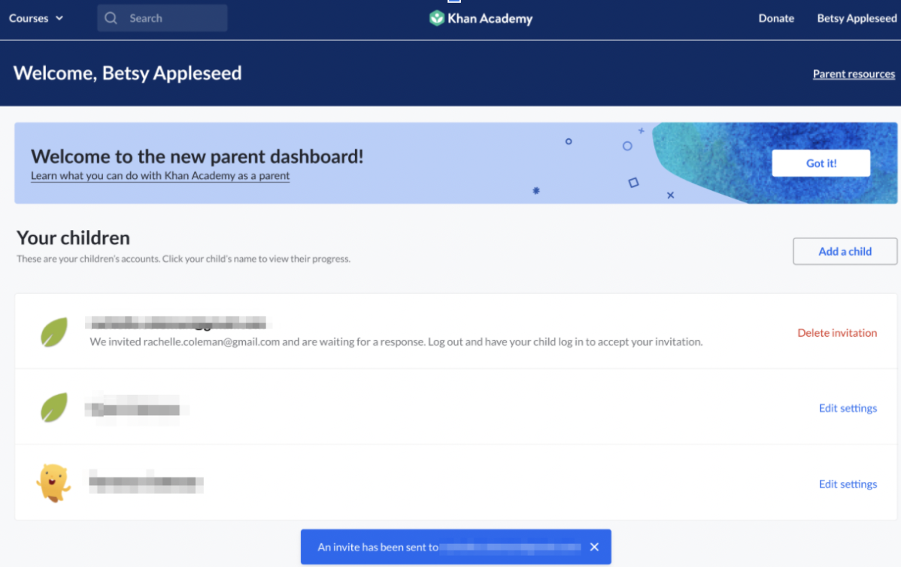

When your child logs in, they’ll see a notification alert next to their name in the upper right corner of the page:

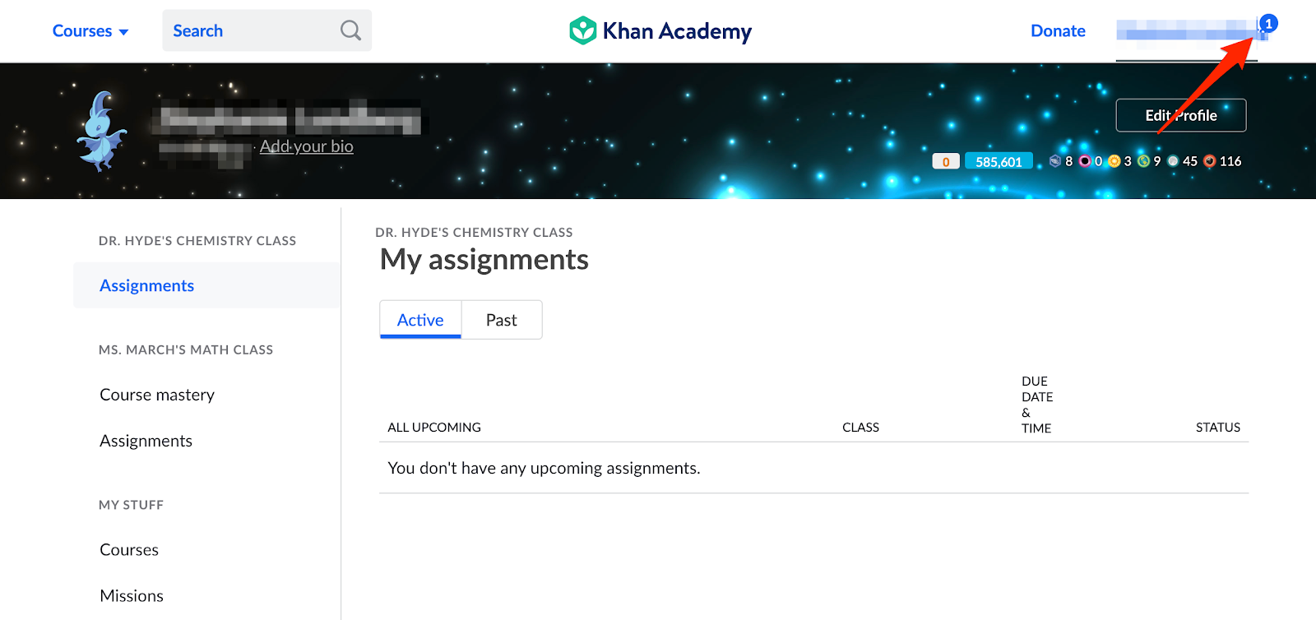

They’ll click on their name, and then the **Notifications** tab, where they’ll find your request to add you as their parent:

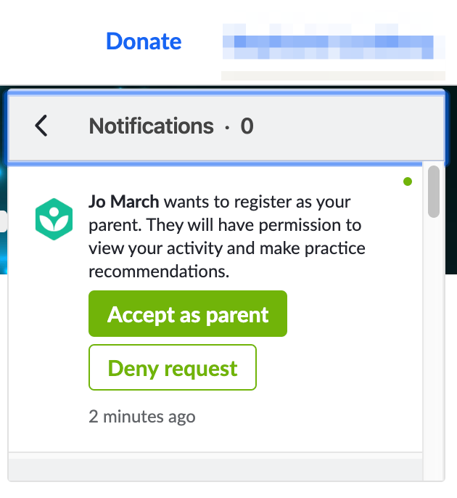

To accept your request, they’ll click on the **Accept as parent** button and see a confirmation message.

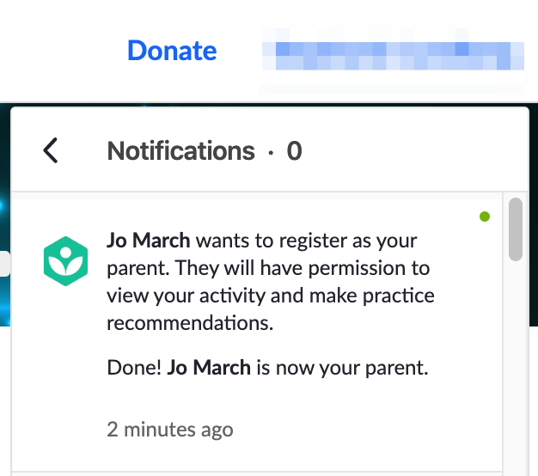

You'll also receive a notification that your child has accepted your invitation the next time you log into your account:

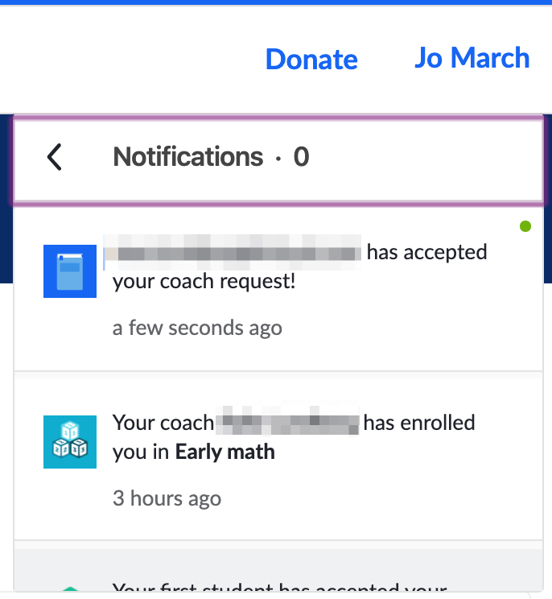

### **Creating an Account for a Child Under 13**

If your child is under 13, they will have a [restricted account](https://support.khanacademy.org/hc/en-us/articles/202262974-How-are-child-restricted-accounts-different-from-regular-accounts-) and you’ll need to create and manage their account.

You’ll be asked to create an username and password for your child, enter their school grade, and their gender (if you don’t want to share that information, that’s fine! Just choose **Not specified**). You can also choose whether to allow your child to add other coaches (such as their teacher or another parent or guardian). When you’re done editing your child’s information, click **Next.**

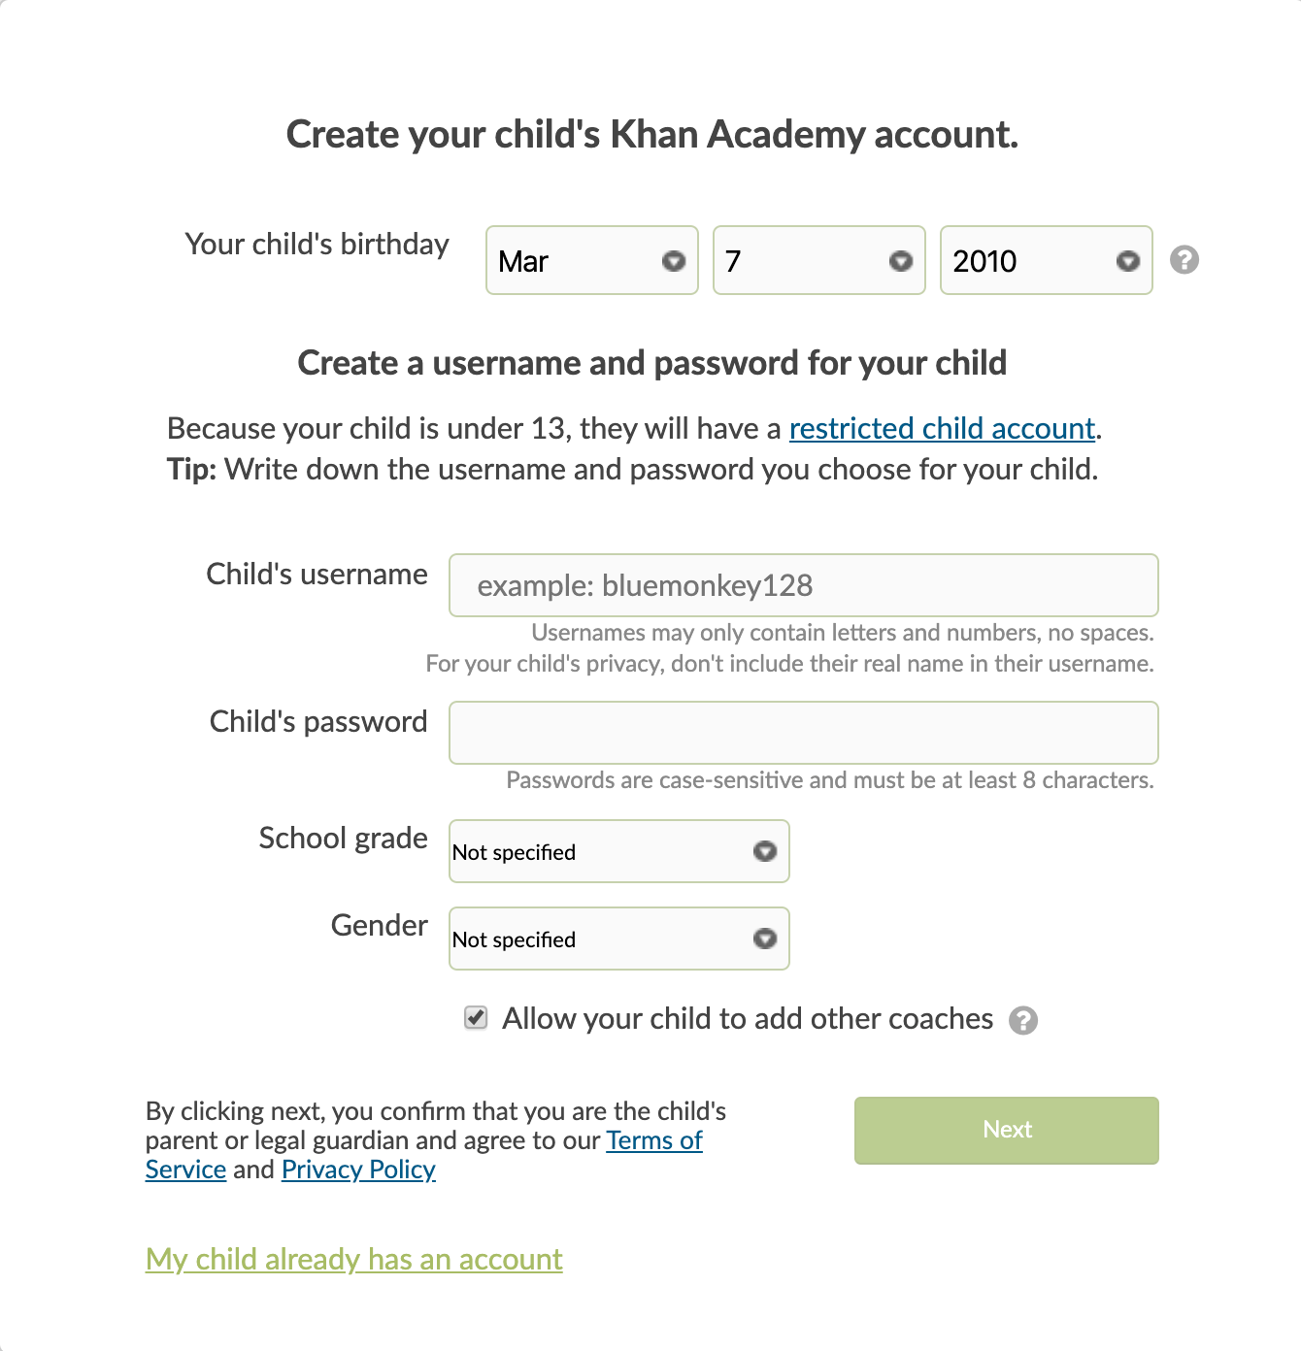

You’ll see a confirmation message, and you can go back to your Parent Dashboard or add another child.

### **Creating an Account for a Child Over 13**

If your child is over 13, they’ll be able to manage their own account. You’ll have the option of creating an account for them, or sending them an email so they can create their account with you already connected as their parent.

Once you enter your child’s birthdate, you will be prompted to send your child an email invitation to create an account. If you prefer to create your child’s account without an email address, click **Create a username and password instead.**

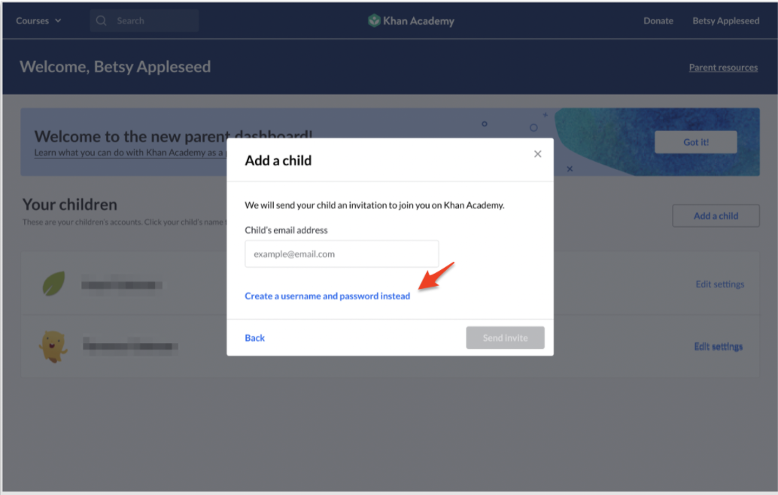

If you choose to create your child’s account with a username and password, you can complete the form and click **Create.**

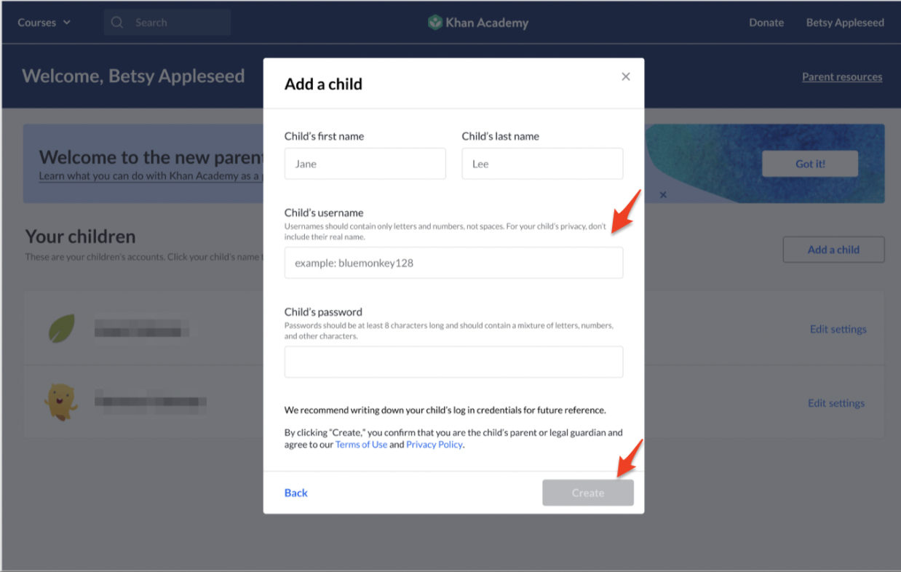

## **Step 4: Helping Your Child Log In**

Now that you’re connected to your child’s account, the next step is to have your child log into their account. If you and your child are sharing a computer, you’ll need to log out of your parent account any time your child wants to learn on Khan Academy.

You can log out from any page by clicking on your name in the upper right corner and then **Log Out**.

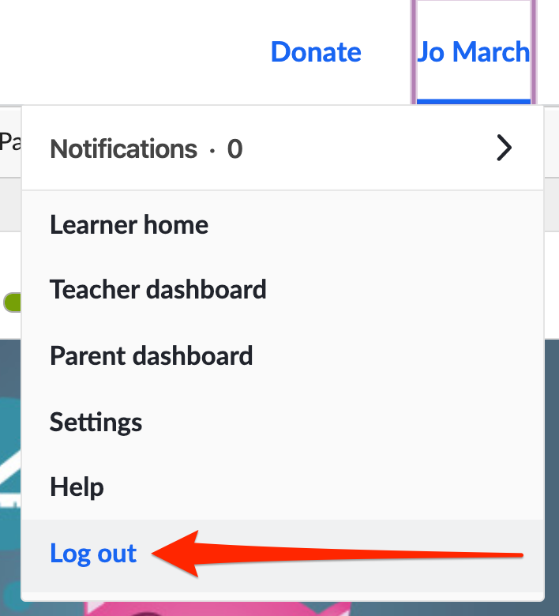

Your child can then log in using the username and password you created for them.

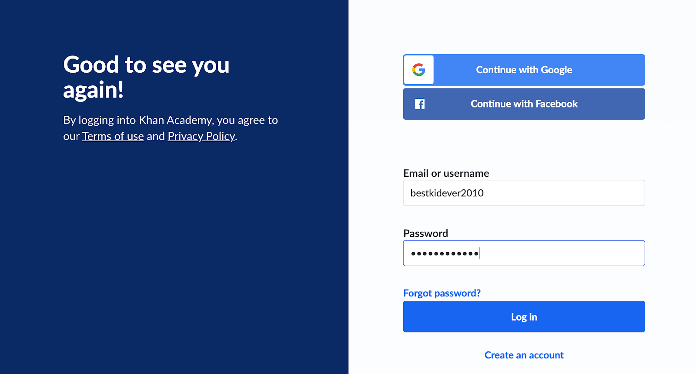

## **Step 5: Understanding Course Mastery**

At Khan Academy, we provide a personalized, mastery-based learning system. Mastery learning means that your child will continue to work on a concept until they can master that concept or skill. You can tell your child has mastered a skill when they apply that skill to successfully complete a job or a task that requires it.

Many of our courses use the Mastery system -- [here’s a full list of courses that use Mastery](https://support.khanacademy.org/hc/en-us/articles/360014675332-Which-courses-have-mastery-enabled-). You and your child can find these courses (and any of our courses) in the **Courses** dropdown menu in the top left corner of any page.

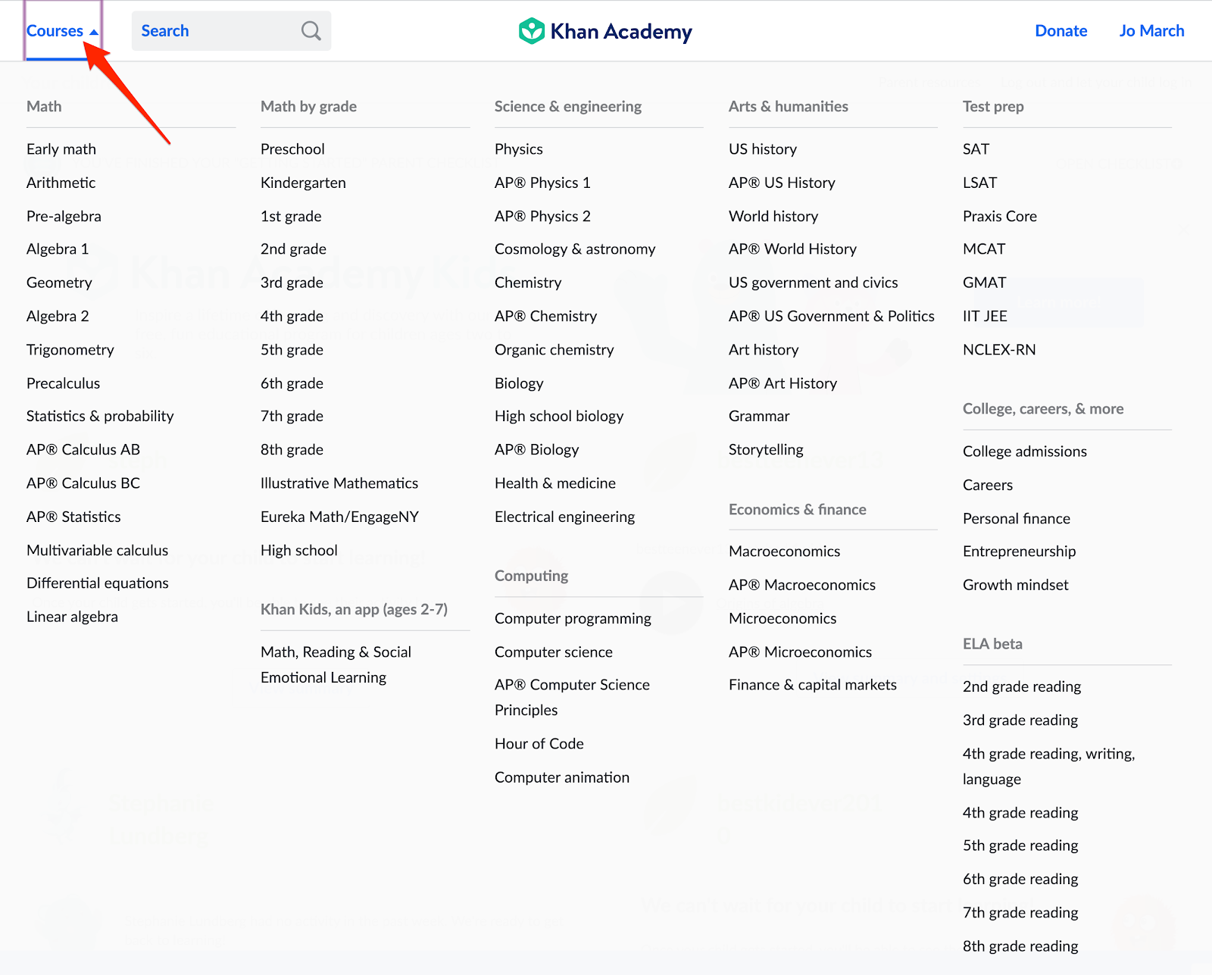

## **Step 5 (continued): Getting Your Child Started with Learning on Khan Academy**

If you’re not sure what course your child should work on, we suggest reaching out to your child’s teacher, if possible, to get their advice on where to start. If their teacher isn't available, look at your child’s homework and ask them questions about the topics they’re covering in class. Look for online resources that match those topics.

To start learning in a course, your child will click on its name in the Courses dropdown menu. In this example, they chose High School Math, so they were taken to the High School Math course page.

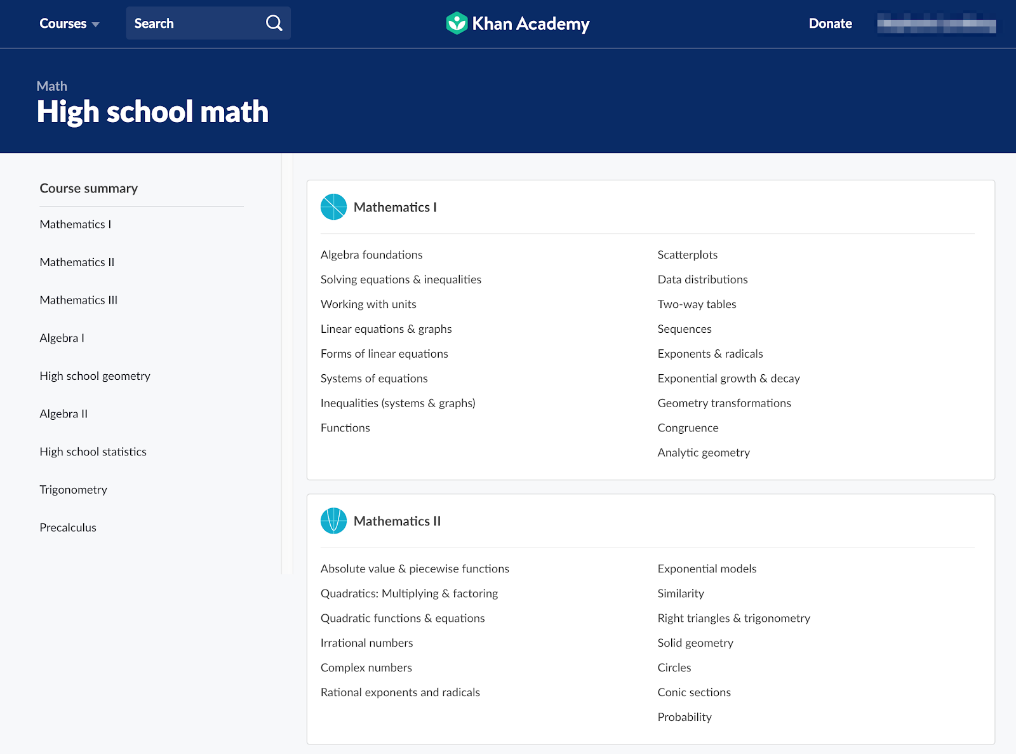

They can then choose the unit they’d like to start learning in. In this example, they chose Mathematics I.

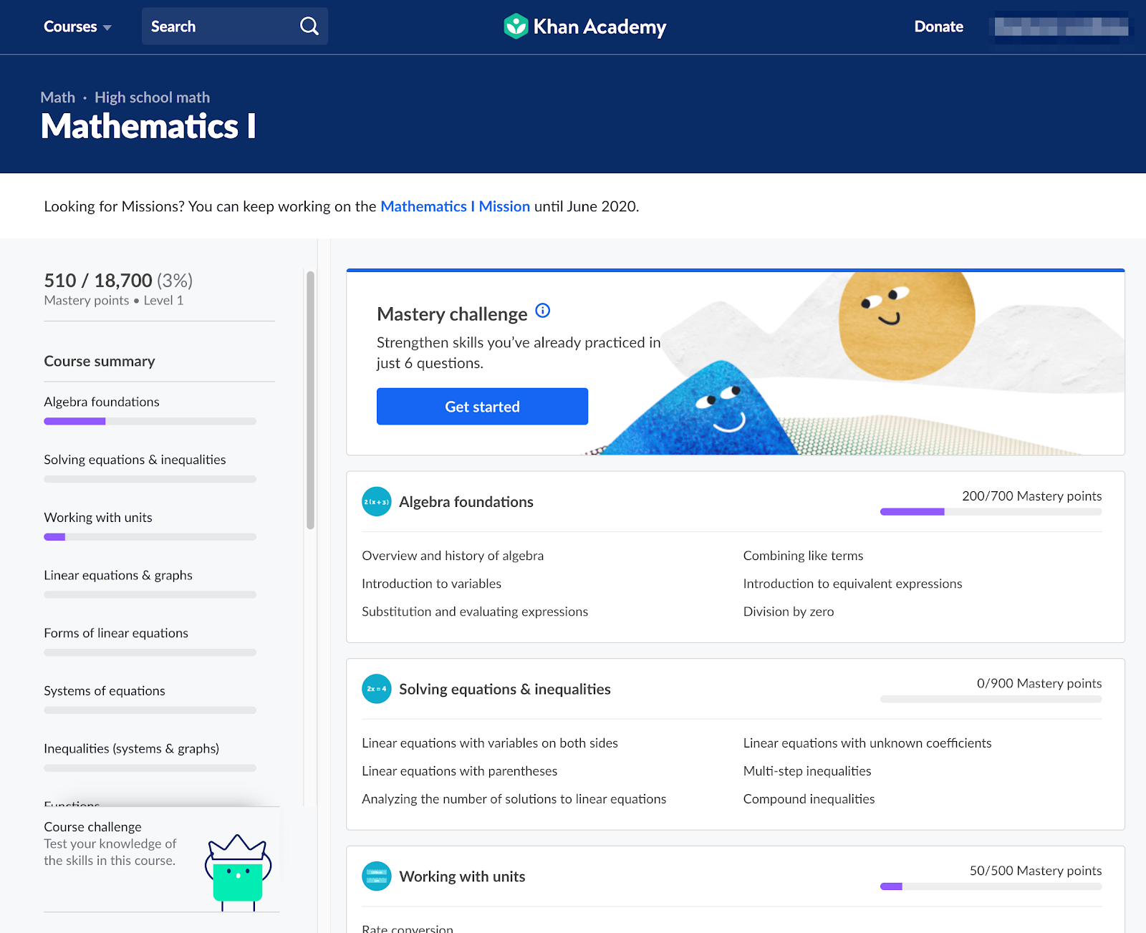

Now that they’re on the unit page, they can choose any video, article, or exercise in the lesson they’d like to work on. In this example, they chose the Overview and history of algebra video under Algebra Foundations.

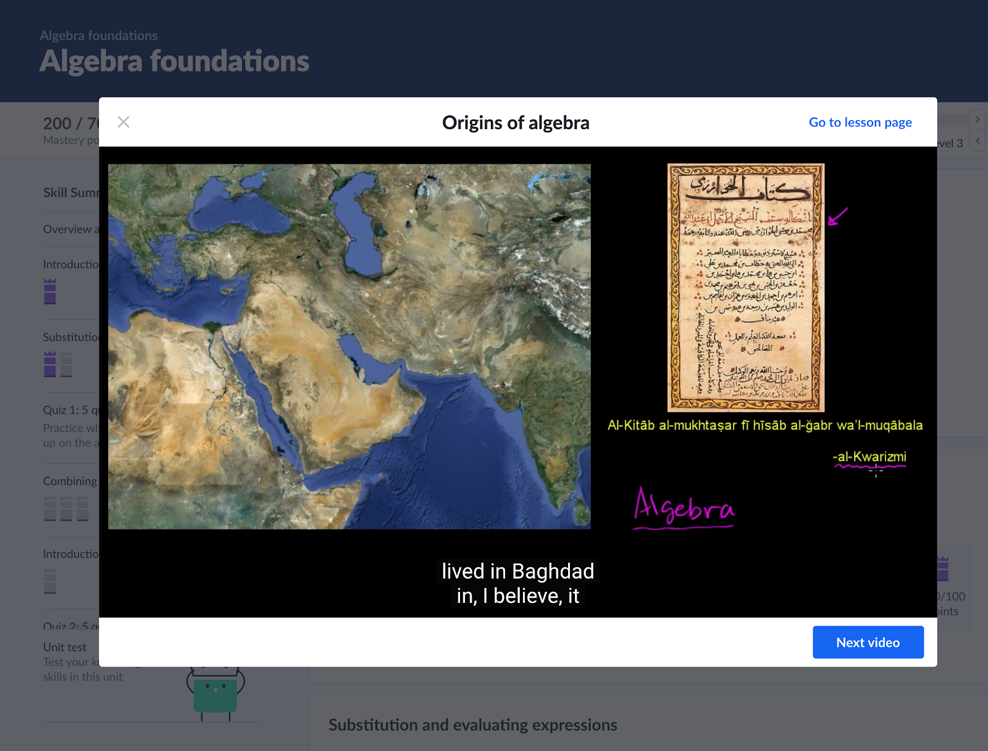

## **Step 5 (continued): Following Your Child’s Progress**

You can view your child’s progress on Khan Academy from your Parent Dashboard. Click on your child’s name to view their activity.

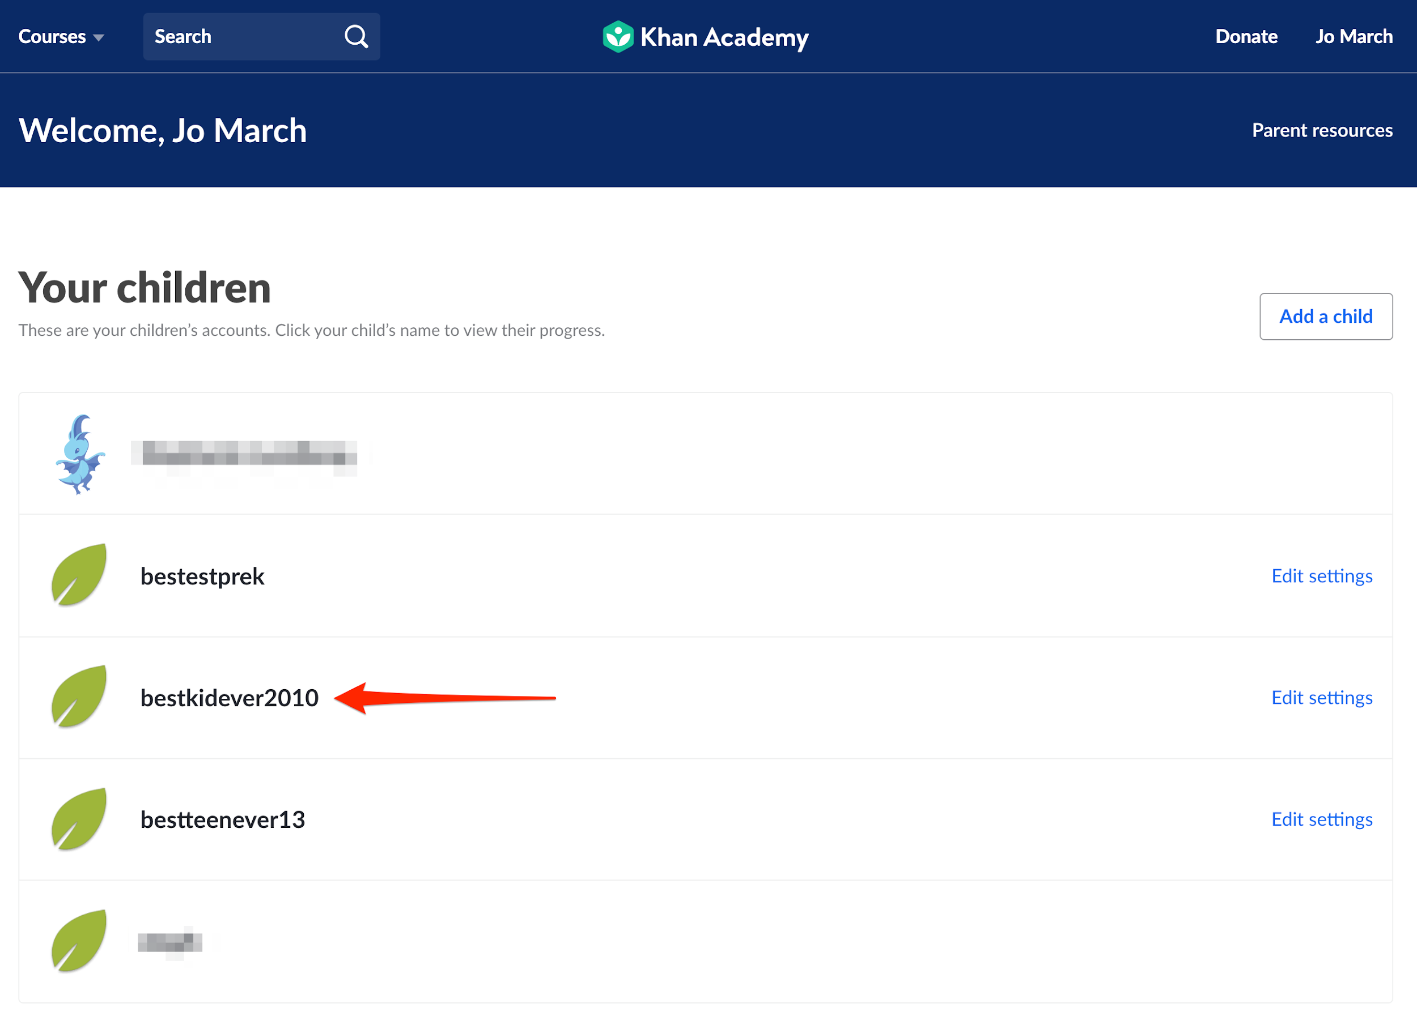

You'll be taken directly to your child's Progress page, but you can also go to their Profile page or their Teachers page from the left side menu.

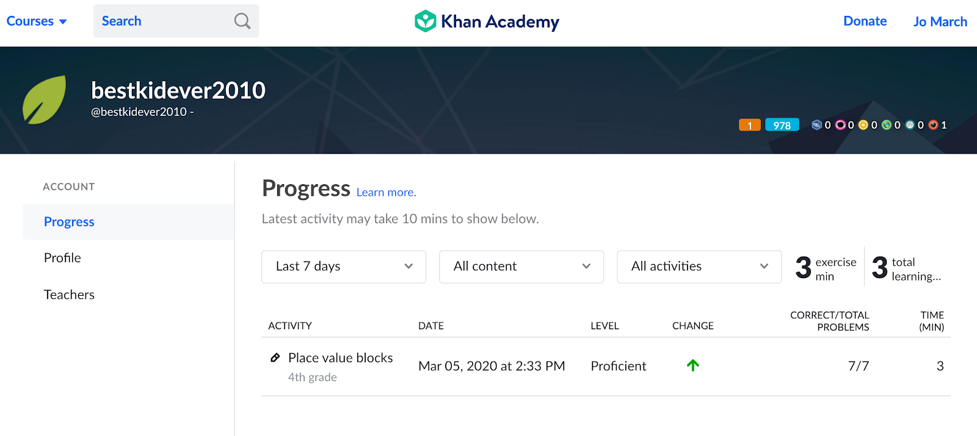

Their progress report allows you to filter their activity by time, content, and activity type (like exercises, videos, articles, quizzes, etc.). You’ll see the name of the activity they worked on, when they worked on it, and how long they worked on it.

Additionally, if the activity involved practicing a skill or answering questions, you’ll see their Mastery level, if there was any change in their Mastery level during the activity (i.e., did they level up or down in Mastery), and how many problems they got correct versus the total number of problems in the activity.

Note that if your child just completed an activity, it might not show up on their progress report immediately; it can take up to 10 minutes for their latest activity to appear.

## **Additional Resources**

We hope this guide was useful in getting you started on Khan Academy. Here are some additional resources to help you manage your and your child’s accounts and help your child get the most out of their learning.

### **Managing Accounts**

* [How can I edit my child's settings?](https://support.khanacademy.org/hc/articles/204795250-How-can-I-edit-my-child-s-settings-)
* [How do I reset my child's password?](https://support.khanacademy.org/hc/articles/202260314-How-do-I-reset-my-child-s-password-)
* [How do I delete my child's account?](https://support.khanacademy.org/hc/articles/360034664112-How-do-I-delete-my-child-s-account-)
* [How do I add or remove coaches on a child account?](https://support.khanacademy.org/hc/articles/202263004-How-do-I-add-or-remove-coaches-on-a-child-account-)
* [Changes to your Parent Dashboard in 2020](https://support.khanacademy.org/hc/articles/360039664491-Changes-to-your-Parent-Dashboard-in-2020)

### **More Learning Resources for Parents**

* [How do I access Khan Academy Kids?](https://support.khanacademy.org/hc/articles/360006897372-How-do-I-access-Khan-Academy-Kids-)
* [What languages is Khan Academy available in?](https://support.khanacademy.org/hc/articles/226457308-Is-Khan-Academy-available-in-other-languages-)
* [Parent's guide to Official SAT Practice](https://www.khanacademy.org/resources/parents-mentors-1/helping-your-child/a/parents-guide-to-official-sat-practice)
* [Stories from parents using KA to tutor](https://www.khanacademy.org/resources/parents-mentors-1/helping-your-child/a/stories-from-parents-using-ka-to-tutor?modal=1)